Title
Requirement
Theory
Diagram
Result
Conclusion
- Connect two computer using straight cable in packet tracer. Verify the connection using Ping Command.(Show all the steps)
Requirement
Cisco packet tracer
Theory
A straight-through cable is commonly used to connect different types of network devices, such as a computer to a switch. In Cisco Packet Tracer, two computers can communicate through a switch by assigning them IP addresses within the same network. The connection can be verified using the ping command, which sends packets from one device to another and checks whether a response is received. A successful ping confirms that the devices are properly connected and can communicate over the network.
Diagram
Result

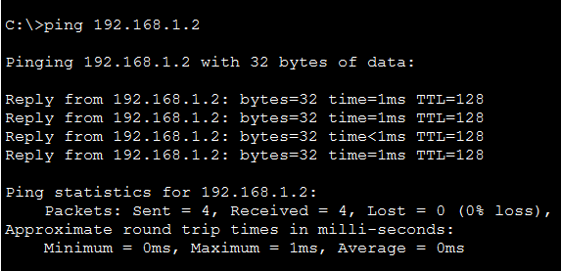

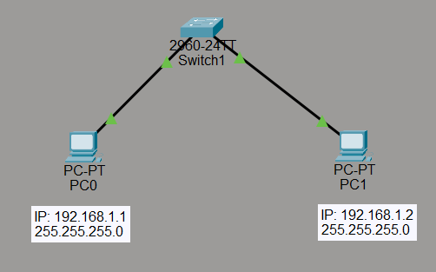
Conclusion
The two computers were successfully connected using a straight-through cable in Cisco Packet Tracer. Their network connectivity was verified using the ping command, and successful replies confirmed that communication between the computers was established. This experiment helped in understanding the basic connection and connectivity verification of computers in a network.

- Connect two computer using cross cable in packet tracer. Verify the connection using Ping Command.(Show all the steps)
Requirement
Theory
A cross-over cable is used to directly connect two similar network devices, such as two computers, without requiring a switch or hub. In Cisco Packet Tracer, two computers can be connected using a cross-over cable and assigned IP addresses belonging to the same network. The connection can be verified using the ping command, which checks whether packets can successfully travel between the two computers. A successful ping indicates that the computers are properly connected and can communicate with each other.
Diagram
Result
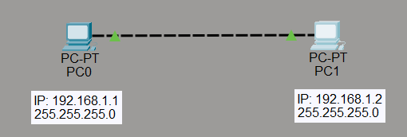

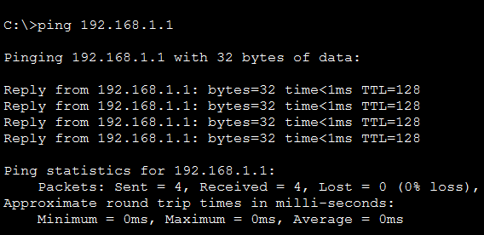
Conclusion
The two computers were successfully connected using a cross-over cable in Cisco Packet Tracer. The connection was verified using the ping command, and successful replies confirmed communication between the computers. This experiment helped in understanding direct computer-to-computer connectivity using a cross-over cable.

- Implementation of Bus Topology
Requirement
Theory
Bus topology is a network topology in which all computers or network devices are connected to a single main communication cable called the bus or backbone. Data sent by one device travels along the shared cable, and the intended device receives the data. Both ends of the bus are normally terminated to prevent signal reflection. Bus topology is simple and requires less cabling, but failure of the main cable can affect the entire network.
Diagram
Result
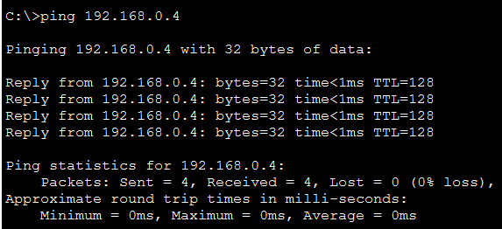
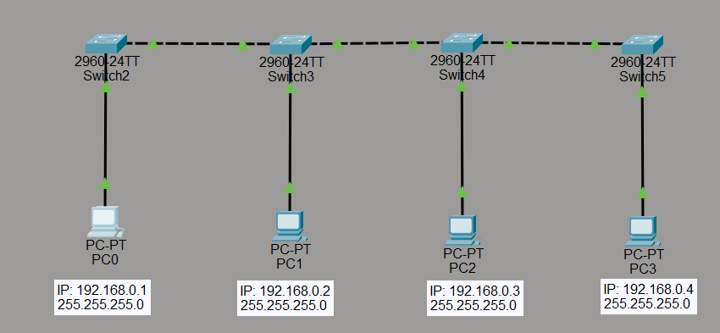
Conclusion
The Bus topology was successfully implemented in Cisco Packet Tracer by connecting the required network devices through a common communication medium. The experiment helped in understanding the structure and working of a bus-based network and how devices communicate through a shared transmission path.

- Implementation of Star Topology
Requirement
Theory
Star topology is a network topology in which all computers or network devices are connected to a single central device, such as a switch or hub. The central device acts as the main point for communication between the connected devices. Data sent from one computer is transmitted through the central device to the destination computer. Star topology is easy to manage and troubleshoot, and failure of one individual connection generally affects only that device.
Diagram
Result
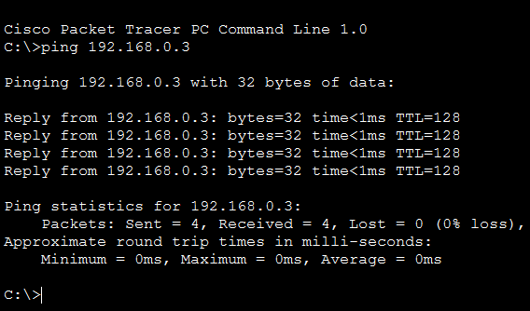
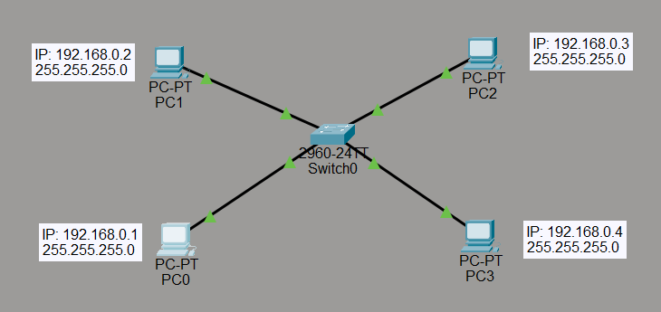
Conclusion
The Star topology was successfully implemented by connecting multiple computers to a central network device. The experiment helped in understanding how a central device manages communication between different computers and demonstrated the basic structure and working of Star topology.

- Implementation of Ring Topology
Requirement
Theory
Ring topology is a network topology in which each computer or network device is connected to two neighboring devices, forming a closed circular path. Data travels from one device to another around the ring until it reaches the intended destination. Each device acts as a part of the communication path. Ring topology provides an organized method of data transmission, but failure of a device or connection can affect communication across the network.
Diagram
Result
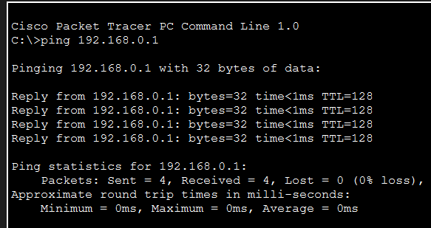
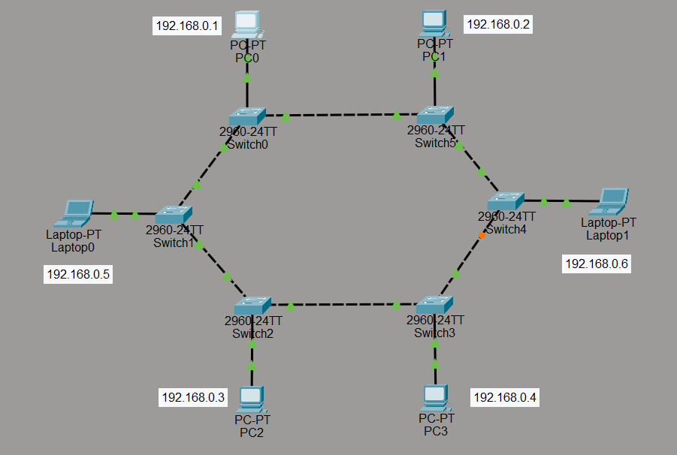
Conclusion
The Ring topology was successfully implemented by connecting the network devices in a circular arrangement. The experiment helped in understanding how devices communicate through neighboring devices and how data travels around a ring network.

- Implementation of Tree Topology.
Requirement
Theory
Tree topology is a hierarchical network topology that combines characteristics of bus and star topologies. In this topology, devices are arranged in different levels, with a central or root device connected to other intermediate devices, which then connect to end devices. It provides a structured way of organizing a network and is suitable for larger networks where devices need to be grouped into different sections.
Diagram
Result
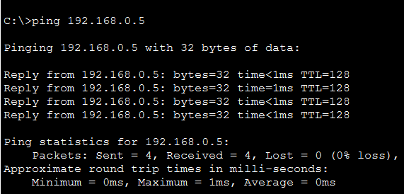
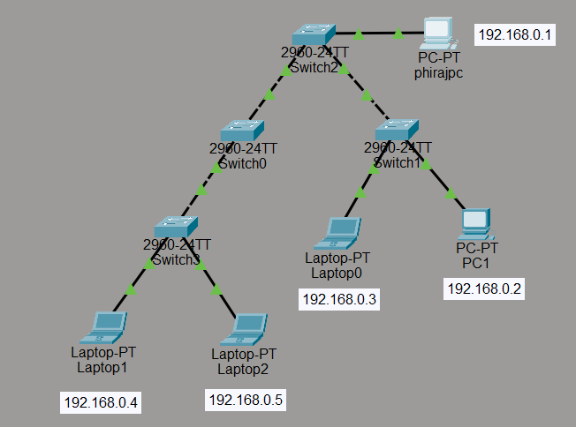
Conclusion
The Tree topology was successfully implemented by arranging the network devices in a hierarchical structure. The experiment helped in understanding how devices can be organized into different levels and how communication can be managed through the hierarchical network structure.

- Implementation of Mesh Topology.
Requirement
Theory
Mesh topology is a network topology in which devices are connected to multiple or all other devices in the network. In a full mesh, every device has a direct connection with every other device. This provides multiple paths for data transmission and improves network reliability. However, it requires more cables and connections compared to other topologies.
Diagram
Result
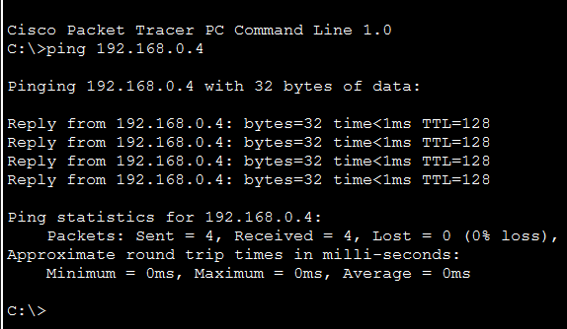
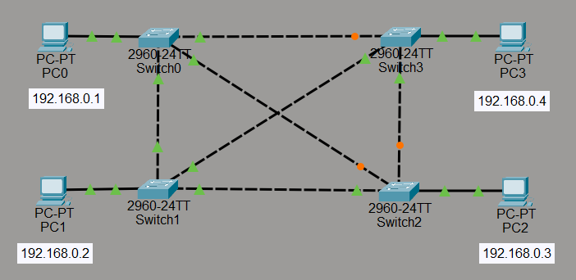
Conclusion
The Mesh topology was successfully implemented by establishing multiple connections between the network devices. The experiment helped in understanding the multiple communication paths between devices and the reliability provided by Mesh topology.

- lmplementation of Bus and Star Topology.
Requirement
Theory
Bus and Star are two common network topologies. In Bus topology, all devices are connected to a single main communication cable through which data is transmitted. In Star topology, all devices are connected to a central device such as a switch or hub, which manages communication between them. Implementing both topologies helps in understanding their different network structures, connections, and methods of communication.
Diagram
Result
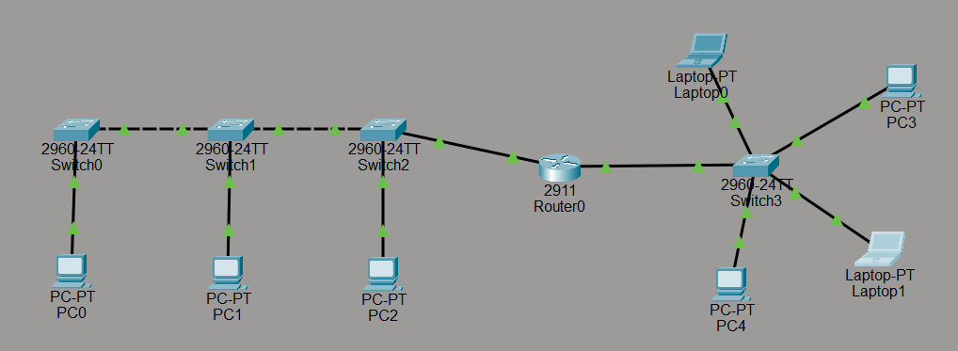
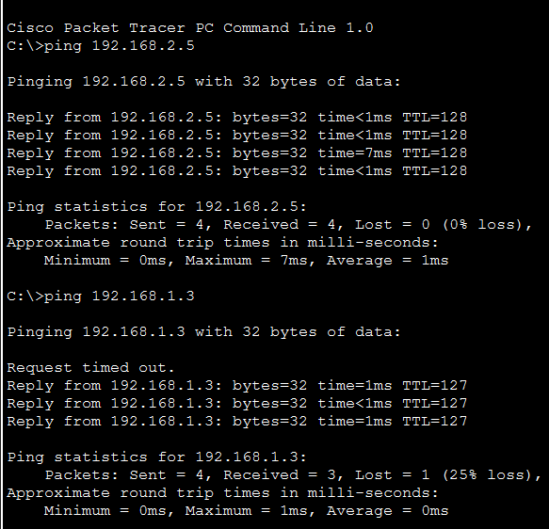
Conclusion
The Bus and Star topologies were successfully implemented and their network structures were studied. The experiment helped in understanding the differences between a shared communication medium in Bus topology and a central device-based connection in Star topology.

- Implementation of RIP Routing in Cisco for Connecting Two Routers
Requirement
Theory
Routing Information Protocol (RIP) is a distance-vector routing protocol used to exchange routing information between routers. RIP determines the best route based on the number of hops, with a maximum of 15 hops. It allows routers to automatically learn and update routes to different networks. In this experiment, RIP routing is implemented in Cisco Packet Tracer to establish communication between two routers.
Diagram
Result
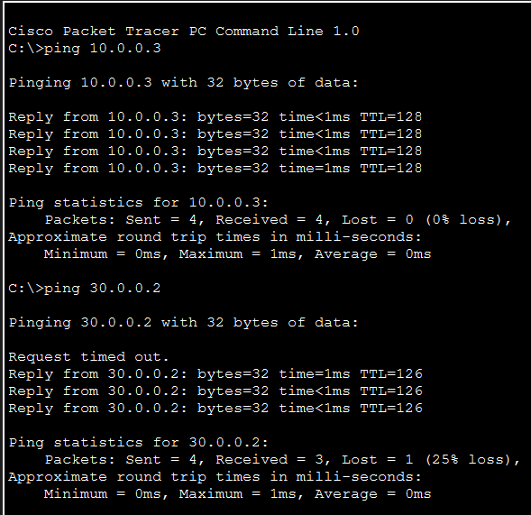
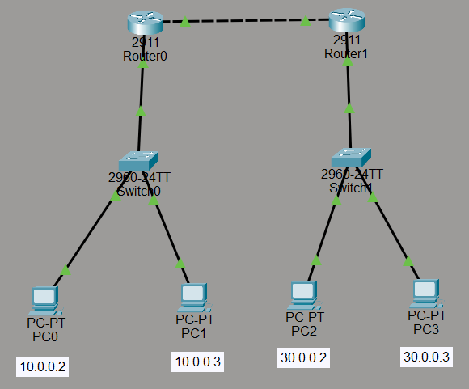
Conclusion
RIP routing was successfully implemented in Cisco Packet Tracer to connect two routers. The experiment helped in understanding how routers exchange routing information and automatically determine routes for communication between different networks.

- Simulate the BGP routing protocol in packet tracer
Requirement
Theory
Border Gateway Protocol (BGP) is a routing protocol used to exchange routing information between different autonomous systems. It is designed for large networks and uses routing information to select suitable paths for data transmission. It is highly scalable and is widely used by Internet Service Providers and large organizations. In Cisco Packet Tracer, BGP can be configured between routers to simulate the exchange of routing information and establish communication between different networks.
Diagram
Result
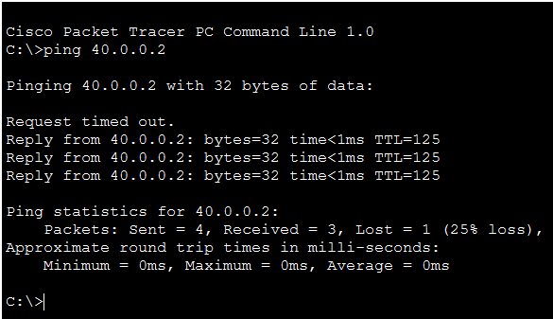
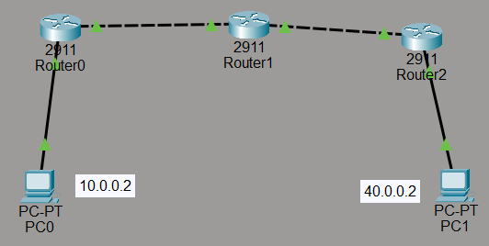
Conclusion
The BGP routing protocol was successfully simulated in Cisco Packet Tracer. The experiment helped in understanding how BGP exchanges routing information between different networks and how routers use this information to establish suitable paths for communication.

- Simulate the ospf routing protocol in packet tracer
Requirement
Theory
Open Shortest Path First (OSPF) is a link-state routing protocol used to determine the best path for data transmission between networks. It uses information about the network topology and calculates the shortest path to a destination using the Shortest Path First (SPF) algorithm. OSPF allows routers to exchange routing information and automatically update their routing tables when network changes occur. It is suitable for medium and large networks because of its efficient routing and fast convergence.
Diagram
Result
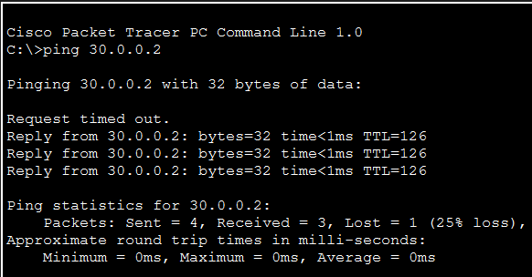
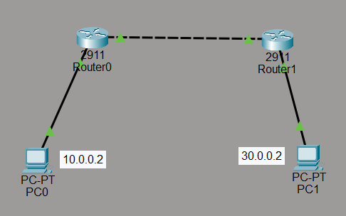
Conclusion
The OSPF routing protocol was successfully simulated in Cisco Packet Tracer. The experiment helped in understanding how routers exchange routing information, calculate suitable paths, and establish communication between different networks using OSPF.

- Implement Static Routing
Requirement
Theory
Static routing is a routing method in which routes are manually configured by a network administrator. Unlike dynamic routing protocols, static routing does not automatically exchange routing information between routers. The administrator specifies the destination network, subnet mask, and next-hop address or exit interface for each route. Static routing is simple and provides greater control over the path taken by network traffic, but it requires manual configuration whenever the network topology changes.
Diagram
Result

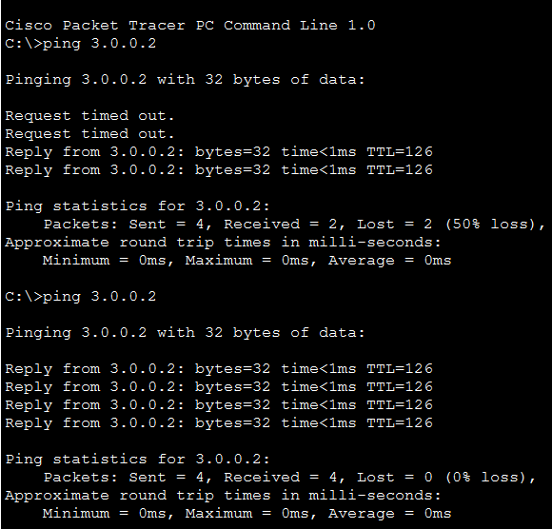
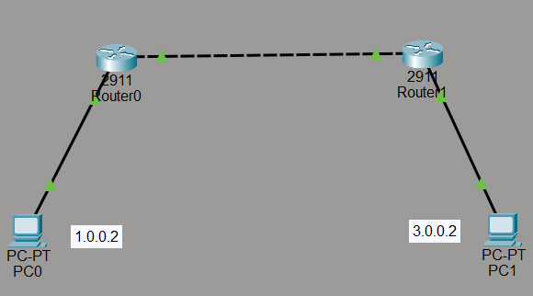
Conclusion
Static routing was successfully implemented by manually configuring the required routes between networks. The experiment helped in understanding how routing tables can be configured manually and how routers use static routes to forward packets toward their destination.

